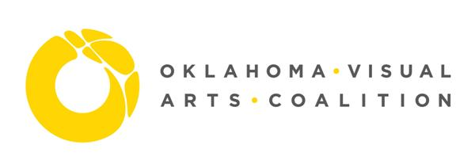

FOR IMMEDIATE RELEASE:
May 28, 2020
Contact: Oklahoma Visual Arts Coalition
Alexa Goetzinger, 405-879-2400
alexa@ovac-ok.org

OK Art Crawl: Discover the Art Next Door

Oklahomans, get ready for the biggest art crawl ever—encompassing the entire state! For the Oklahoma Art Crawl, on June 27 and 28th from 5pm-8pm, artists all over the state will be displaying their art outdoors—in their windows, on their porches, in their driveways—so that Oklahoma residents can Discover the Art Next Door.

Organized by the Oklahoma Visual Artists Coalition, this free event is open to any artist who applies by June 12th and follows the guidelines. Participating artists will be listed on OVAC’s website, as well as an illustrated Google map. Visitors can use the map to check out artists close to them—or new areas they might want to visit!

“COVID-19 has forced arts organizations to get creative in how we offer arts experiences for the public. We hope this is a valuable experience for both the public and the participating artists. While digital platforms are a great way to have a far reach, there is no substitute for experiencing art in person,” stated Krystle Brewer, Executive Director for the Oklahoma Visual Arts Coalition.

Everyone is welcome to enter and there is no fee to participate—this is an inclusive statewide event for all Oklahoma artists.

“So many community festivals and other arts events have been cancelled by the COVID-19 pandemic. We wanted to create opportunities for Oklahomans to see art in person, safely, and for Oklahoma artists to show—and hopefully sell—some of their work,” says independent curator Jennifer Scanlan, who is helping to facilitate the program.

OVAC is partnering with a number of other organizations to spread the word and make this event a truly Oklahoma-wide celebration of the arts, including ahha Tulsa, Allied Arts, Arts Council Oklahoma City, Art Group OKC, Edmond Fine Arts Institute, Firehouse Art Center, Living Arts of Tulsa, Norman Arts Council, Oklahoma Arts Council, Oklahoma Arts Institute, Paseo Arts Association, Plains Indians and Pioneer Museum, Prairie Arts Center, The Art Hall, and The Vault Art Space and Gathering Place.

To participate as an artist, join as a partner, or for more information about the event, visit OKArtCrawl.org.

###

Image Credits:
- OK Art Crawl logo, provided by OVAC
- romy owens, Under Her Wing Was the Universe, public sculpture, photo provided by artist
- Kristin Gentry, Indian Blankets, Acrylic, 11”x 14”, photo provided by artist
- Virginia Sitzes, participating artist in her studio, photo provided by artist
- Jason Wilson, Native Thunder, Acrylic, image detail, photo provided by artist
- Alexa Goetzinger, mock set up of Art Crawl on front porch, photo provided by OVAC

